On March 4th, Northern Branch Power Pioneers Al Beeson and Tim & Gail Thompson attended the 45th Central Interior Science Exhibition at the University of Northern BC.  Although the number of Science exhibits were down from previous years, the enthusiasm of the students with their exhibits was fantastic. This year we noticed many students with were from several outlining communities.  These communities included Valemount, Mackenzie, Vanderhoof, Fraser Lake, Burns Lake and even the small community of Decker Lake.  
  
There were less judges at this year’s exhibition; Al and Tim volunteered in the medal round competition.  They were teamed up with other volunteers and between them they judged a total of 16 exhibits.  The students they judged were from grades four and five.  Some of the Science projects they judged included; the strength of different shopping bags for shopping; finding out if we can make fertilizer from household waste (coffee grounds, egg shells, etc.); finding out if you can get electricity from potatoes and lemons to light a light bulb.  
  
That evening they attended the awards ceremony to present the Power Smart Perpetual Trophy, Certificate and Power Pioneer $100 cash award.   Al Beeson (Northern Branch President) presented the award to Kieran McDonald a grade four student from Decker Lake Elementary School.  Kieran McDonald’s science exhibit was on finding out if you can get electricity from either potatoes or lemons to light a light bulb when he goes camping.   Kieran was awarded a silver medal and two special awards, one of which was the Hydro Power Pioneer award for his project.

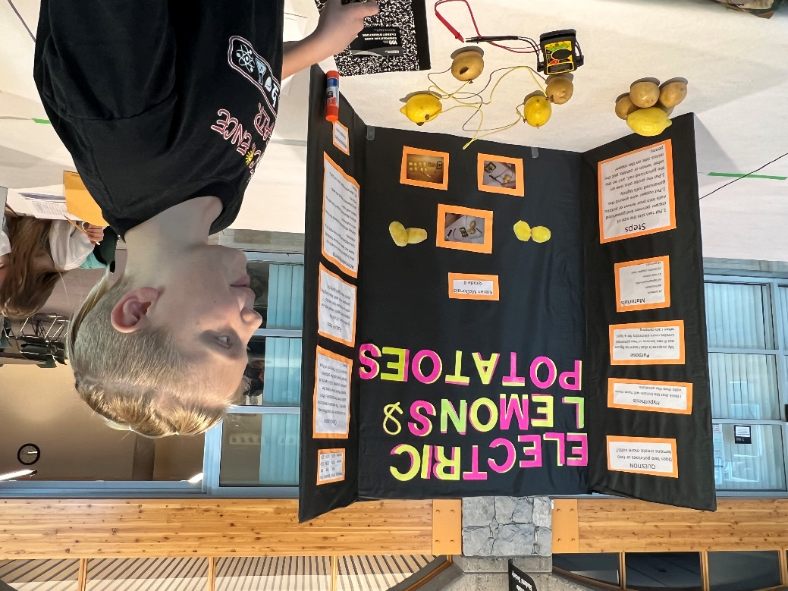Kieran McDonald’s science exhibit was on finding out if you can get electricity from either potatoes or lemons to light a light bulb when he goes camping.

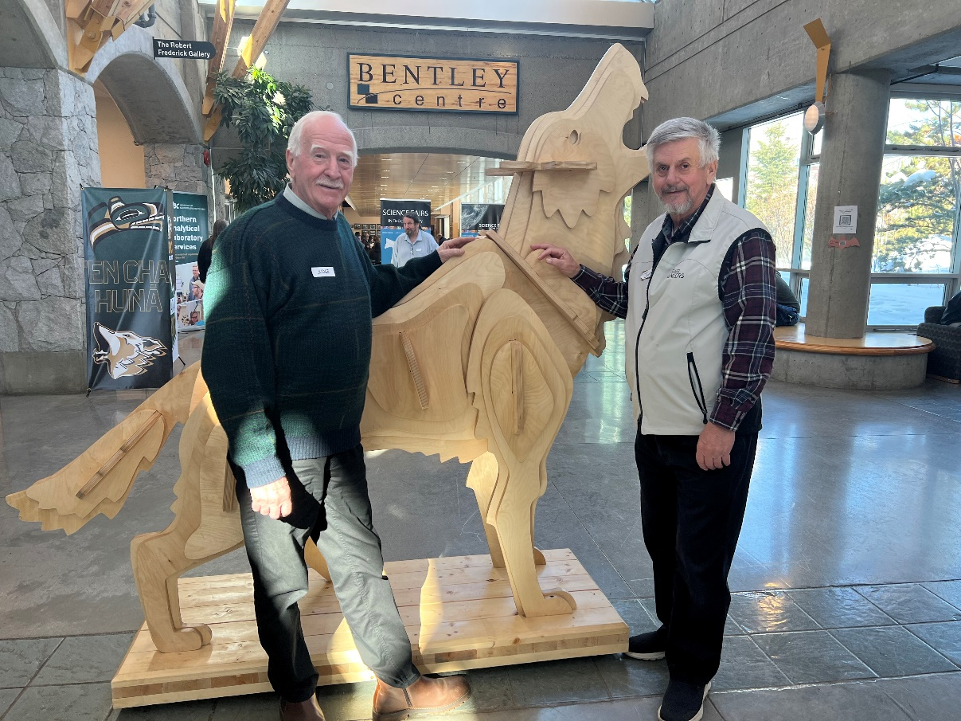Al Beeson and Tim Thompson attended the 45th Central Interior Science Exhibition at the University of Northern BC

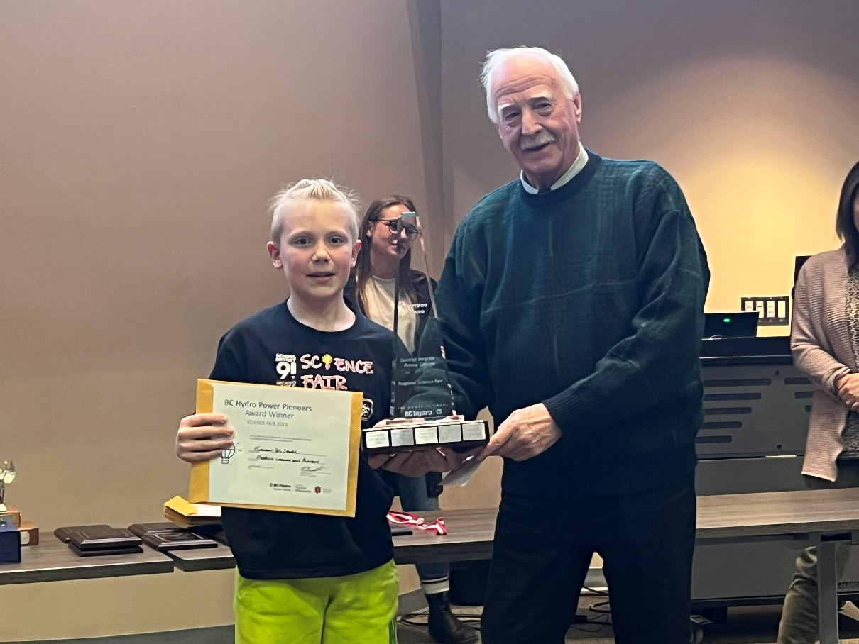  
Kieran McDonald was awarded a silver medal and two special awards. One of these was the Hydro Power Pioneer award presented by Al Beeson

Photos taken by Gail Thompson.

Submitted by - Tim Thompson Northern Branch Science Chair